Structural Examination of Easel Paintings with Optical Coherence Tomography

Gabrielle Feldman

12/05/2021

Introduction

Most art conservationists rely on measurements that are non-destructive and can be portable. The field of portable spectroscopy has continued to grow, and non-destructive instruments offer conservators a solution to sample their artifacts while maintaining the object’s integrity.

Optical coherence tomography (OCT) is a relatively new technique in the conservation field to help conservators analyze their samples and provide more information. X-ray radiography and infrared reflectography were commonly used before OCT, but they did not give information about the cross sections, which can be used to determine a chemically appropriate conservation method. 1 When using x-ray radiography or infrared reflectography, small pieces are taken from the canvas for sampling causing damage to its structural integrity.

Common multi-spectral imaging techniques require one to subtract the optical interference of varnish layers, which are used as a final layer to a painting. Varnishes yellow overtime as they age, which leads to cracking on the surface due to expansion. OCT provides curators a method to determine the optical thickness of the surface.2

OCT also allows for examination of the underdrawings and varnish layers to be observed. These underdrawings give insight into the artist’s intent for the painting and provide historical context. The two canvases sampled from Targowski and their results suggest that OCT is a promising method of data collection in art conservation applications.

Theory

In an OCT reading, the light has a narrow frequency bandwidth and the source of it stems from a laser with low temporal coherence but high spatial coherence. This light is pointed toward the surface of the canvas, and the recombination of the reflected light with the reference light yields an interferogram with a z axis. When the two light beams interact, the path lengths are within a few microns of each other, which allows for the z axis to image to depths in the micrometer range. 1

The laser had a wavelength of 845 nm with a $Δλ_{FWHM}$ of 107 nm, which is in the near-IR region and low in energy.1 OCT will not damage the surface, but also allows for penetration through the paint, making it an obvious choice for conservationists. IR absorption occurs when the electric field vector and the molecular dipole interact with each other.3 To maximize the absorption of a surface, the electric field and dipole moment vectors must be parallel; the polarization is the direction in which the electric or magnetic fields oscillate. 4

Interference describes the relationship between both electromagnetic waves in the setup: they superimpose to form a vector wave of greater amplitude upon hitting the sample. When the two light sources interfere with each other fringes of contrasting light and dark patches appear that allow for the interference to be measured. 5Interference between the reference and object arms in OCT produces the signal for the cross section.

The final interaction this measurement relies on is reflectance, which is a measure of how well the surface reflects radiant energy. The reflectance varies depending on the light’s frequency, wavelength, polarization, and angle of incidence. 6 This feature allows for imaging of sub-surface layers and gives rise to the cross sections needed to build the three-dimensional image.

Instrumentation

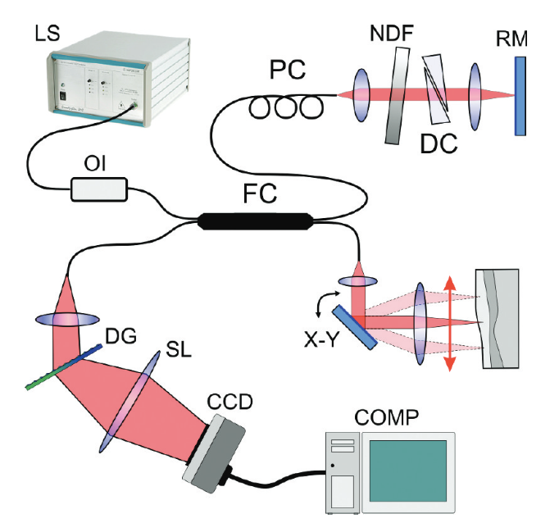

*Figure 1.* Diagram of OCT setup1 LS, light source; OI, optical isolator; FC, fiber coupler; PC, polarization coupler; NDF, neutral density filter; DC, dispersion compensator; RM, reference arm mirror; X-Y, transversal scanner; DG, diffraction grating; SL, spectrograph lens, CCD, linear CCD camera

This OCT measurement begins with a laser at .1 Light travels through an OI, forcing it to travel in one direction to prevent unwanted feedback.7 The interferometer used for this measurement was a Michelson interferometer with a 50:50 FC which divides the light into reference and object arms.1 On the RM, a PC controls the polarized state of light. 8 The ND filter reduces the intensity of all wavelengths to reduce the amount of light entering the lens, achieving shot noise limited detection. 9 The DC reduces the temporal broadening, keeping the signal free of distortion.10

The object arm uses a lens that forms a narrow probing beam on the canvas with an X-Y that scans the beam across the canvas.1 The back reflection from the RM and backscattering from the structural object return to the FC and interfere.1

The application of a CCD camera in a custom-built spectrograph helps to extract structural information, since its metal-oxide-semiconductor capacitors are biased above the image acquisition inversion threshold. This allows for the incoming photons to convert to electron charges.11The holographic DG with 1200 groves/mm and achromatic SL focused the spectrum onto the 12-bit single-line CCD camera. A Fourier transform of the interference signal yields the cross-sectional image. Moving in perpendicular directions, the X-Y yields a 2-D cross-sectional image. Combined, a 3-D tomograph is constructed within seconds.1

To customize a measurement to a sample, several parameters in OCT can be optimized. The full-width half-maximum spectral bandwidth and coherence length were fine-tuned based on previous work with easel paintings.2,12 The power at the sample can be adjusted by varying laser sources, and the illumination spot diameter can be controlled with varying the lens. Finally, the CCD camera allows for adjustments in integration time and scan length to occur.13

These parameters that can be adjusted in OCT are simple enough for non-professionals and conservation staff to use, and depth measurements can be made within seconds. With quick measurements, OCT provides more information than previous conservation instrumentation. In terms of instrumentation layout, the authors make a cohesive argument for the implementation of OCT to the field.

Signal Quality

The signal begins from a 845 nm laser in the Michelson Interferometer, and produces a signal $I_{0}=\left|E_{r}^{2}\right|+\left|E_{s}^{2}\right|+2E_{r}E_{s}cos⁡(2kΔL$), where L is the effective pathlength inside of the interferometer, and the energy produced by the two beams after going through the beam splitter.14 Next, the signal travels through an optical isolator where it is forced to propagate in only one direction. The central fiber coupler sends the signal to both reference and sample arms.

The reference arm contains a polarization controller that controls conditions for interference, a neutral density filter to adjust the light power for shot noise detection, and a block of glass to act as a dispersion compensator. The signal sent from the reference arm is . 14

The signal on the object arm arrives at the transverse scanner, which samples the canvas in the x and y directions. The signal produced from this detection is represented as . 14This signal and the one from the reference arm are sent back to the fiber coupler and towards the computer for processing. Upon interacting together, a superposition of the two signals emerges and provides data for the z direction of the canvas. This interaction shown by .1 The full width half maximum is defined as $Δτ_{FWHM}=\frac{8\ln{2}}{Δω_{FWHM}}$. 1

After this interaction, photons are sent through a diffraction grating and spectrograph lens. Upon hitting the surface of the CCD camera, the signal is defined as .14

The final interference term is multiplied by a strong reference signal ${(I_{r}I_{n})}^{.5}$ due to the limited shot noise of this method.1 Shot noise is impossible to ignore in this instrumentation because it occurs when there is a potential barrier, and PN diodes are commonly used fiber couplers. As the electrons and holes cross this barrier, shot noise is produced due to changes in flux. The current’s flow will not be continuous and is limited by the number of photons at the detector. This is given by . 15Shot noise is the most significant noise source in this measurement, so the final signal to noise ratio is given as:

$$\frac{I_{ω}=I_{r}\left(ω\right)+\sum_{n}{I_{n}\left(ω\right)+2\sum_{n}{[√I_{r}\left(ω\right)I_{n}\left(ω\right)cos⁡(ωτ_{n})]}}}{2eI^{0}A^{2}}$$

where for A, the area of a circle should be assumed.

Analysis

*Figure 2.* Picture of the two canvases presented in this study: *Saint Leonard of Porto Maurizio* and *Portrait of an Unknown Woman*.1 The regions where the first canvas was sampled is shown in red.

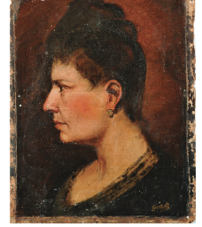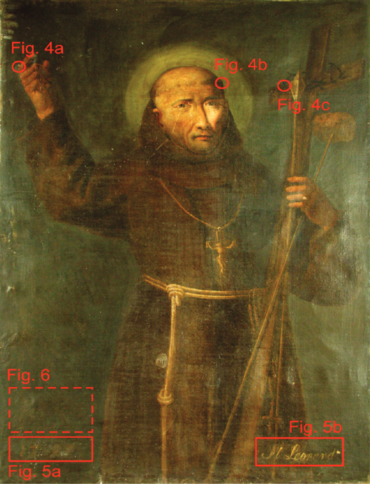

Not only does the instrumentation rationale support the application of OCT to conservation of paintings, but the data produced supports these claims. Figure 2 shows two paintings of interest: Saint Leonard of Porto Maurizio and Portrait of an Unknown Woman.

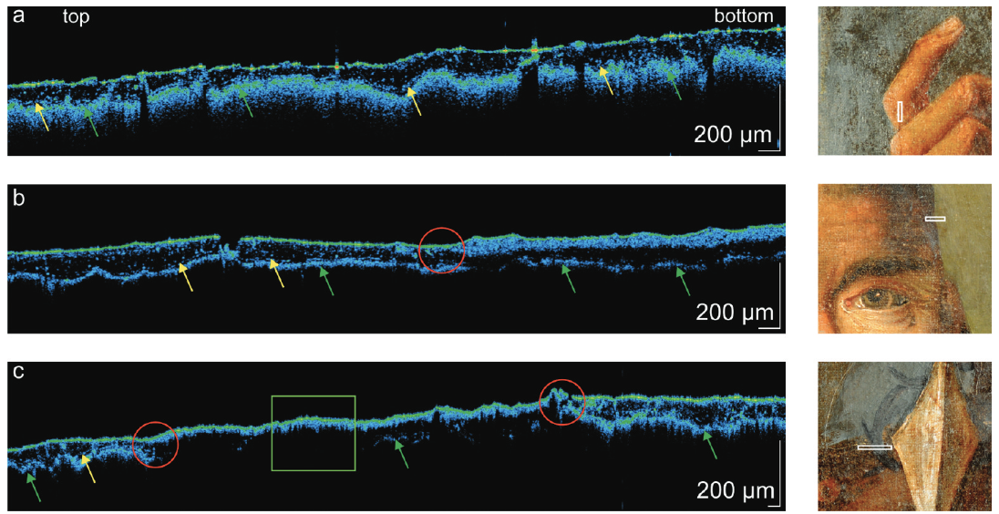

Figure 3. Tomograms from Saint Leonard of Porto Maurizio are presented here. a. Here the paper claims this is the multilayered varnish layer. b. Overpainting layer c. Opaque overpainting. The yellow arrows refer to varnish layer, green shows the opaque paint layer, circles show boundaries between original and overpainted areas and rectangles refer to the region where the overpainting is opaque.1

The first painting depicts a Franciscan monk, Leonard of Porto Maurizio, and has an inscription is of dubious origin, and is suspected of being added later.1 Tomograms of his head, A picture containing text, tree
finger, and cross were presented. In Figure 3, the tomogram does show distinct layers when looking at the coloring. The paper does not explicitly state what the different colors in the tomogram refer to, however, 4 layers can be observed. These can be differentiated by the dotted particles present in the tomogram as these are dirt particles that become trapped under varnish layers. The green layer is the most continuous one and can be assumed to be the most recent varnish layer on the painting and was well dried. The variation in particle accumulation can be attributed to separate conservation efforts applied to this painting over the years. The green region refers to the original painting, although even with the arrows in the paper, this distinction is not that apparent. Overpainting can be observed since the way in which it interacts with light is different and displays a blue colored layer. Different paint formulations can result in different absorbencies, and therefore support the claims that overpainting renovation was performed.

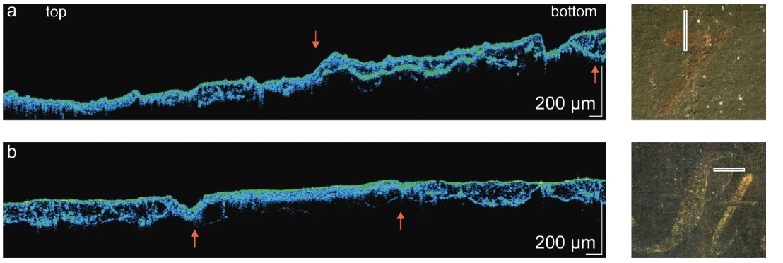

*Figures 4 and 5.* Tomograms from the overpainted inscriptions from *Saint Leonard of Porto Maurizio.* 4a shows the first digit 7 from the date 1797, found between the red arrows. 4b. letter S from the text *St. Leonard*, where S is found between the red arrows. 5a. letter D is seen from conventional UV analysis 5b. OCT tomogram reconstructed by extracting the signal from all the depths between 137-145 μm. 5c. Lateral scan of the letter D from OCT

Figure 4 and 5 displays the tomograms taken from the signature. Again, the order of the layers provides insight into previous restoration efforts and is in line with the previous findings from Figure 3. During its historical conception, this canvas would routinely go unsigned, and this signature is an oddity in this context. The previous data shows that this canvas was overpainted twice and revarnished three times. The date was analyzed under OCT, but only the 7 was able to be deciphered. The tomograms of the other numbers are not presented and could provide further insight to conservators on what sub-optimal measurements look like. The second inscription was the letter S from bottom left corner. This letter was found in a varnish layer, which is proof that it comes from a time after the original painter.

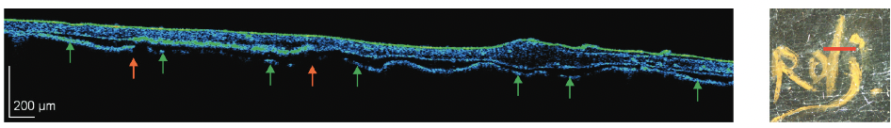

Figure 6. OCT tomogram presented from Portrait of an Unknown Woman over the letter “d” of the signature. Green arrows show the opaque paint layer.

The Portrait of an Unknown Woman didn’t have the same amount of data presented; however, the findings are like the ones found on the other canvas. Analysis of the signature from Figure 6 shows the OCT measurement. Although it is not visibly legibly, shadows can barely be made out. Since the overpaint covers the signature, OCT did not provide conclusive evidence, which is one drawback in this analysis. However, this does show that this canvas had an overpaint layer applied at another time, which does support the usefulness of this technique.

Normally with OCT, values for the frequency time domain, amplitudes and phase detection noises would be reported to compare the signal to noise ratio. 16 These could be used to calculate the precision of the measurement and to see how well this method truly worked. However, all of the data collected was qualitative in nature and cannot be quantified.

Conclusion

Overall, Tarnowski’s work shows promising data to support OCT applications in art conservation. The data captured for Saint Leonard of Porto Maurizio clearly demonstrates this benefit: clearly defined segments and high resolution to see particles within layers. This does have an obvious benefit since a nondestructive method is far superior to previous work. Commonly, conservationists relied on taking physical samples of surfaces to determine this information!2,12

However, the dataset presented from the Portrait of an Unknown Woman did not add to the overall narrative of the paper. While it is important to showcase data that is not as clean if widespread adoption of OCT is the goal, this application was novel for the time. The contrast between UV and OCT measurements were not as developed. This comparison is needed because it shows the conservation field’s most common instrumentation to this new method. By developing this contrast and showcasing promising data on the previous canvas, the argument is enhanced and would encourage labs to spend money to acquire OCT.

Overall, this paper provides a great example of how to craft an effective argument that not only captures analytical chemists, but other scientists who would benefit from this instrumentation. While a lot of the data is very promising and having the hindsight of where the art conservation field is now compared to 2004, the argument fell flat. The importance of being able to be critical about the data in this paper can be seen as well; while showcasing data is important, scientists will want to apply instrumentation with clear evidence and a contrast to their current work. Through a careful analysis of the data, some factors such as the coloration of the tomographs and the fact that the chemical reason why the varnish on one sample could be measured but on the other it couldn’t doesn’t show the true nuances in samples. Without this kind of data to support the claim, many would not be willing to apply this method to their work because it needs to be able to be adjusted to handle any chemically unknown surface. However, it sets the stage for obvious future work in adjusting their measurements for the different samples.

Works Cited

(1) Targowski, P.; Iwanicka, M.; Tymińska-Widmer, L.; Sylwestrzak, M.; Kwiatkowska, E. A. Structural Examination of Easel Paintings with Optical Coherence Tomography. Accounts of Chemical Research 2010, 43 (6), 826–836. https://doi.org/10.1021/ar900195d.

(2) Liang, H.; Cucu, R.; Dobre, G. M.; Jackson, D. A.; Pedro, J.; Pannell, C.; Saunders, D.; Podoleanu, A. G. Application of OCT to Examination of Easel Paintings. In Second European Workshop on Optical Fibre Sensors; SPIE, 2004; Vol. 5502, p 378. https://doi.org/10.1117/12.566780.

(3) IR Absorption - an overview | ScienceDirect Topics https://www.sciencedirect.com/topics/chemistry/ir-absorption (accessed 2021 -12 -11).

(4) Polarized Light - an overview | ScienceDirect Topics https://www.sciencedirect.com/topics/chemistry/polarized-light (accessed 2021 -12 -11).

(5) interference fringe | physics | Britannica https://www.britannica.com/science/interference-fringe (accessed 2021 -12 -11).

(6) Reflectance - Wikipedia https://en.wikipedia.org/wiki/Reflectance (accessed 2021 -12 -11).

(7) Jalas, D.; Petrov, A.; Eich, M.; Freude, W.; Fan, S.; Yu, Z.; Baets, R.; Popović, M.; Melloni, A.; Joannopoulos, J. D.; Vanwolleghem, M.; Doerr, C. R.; Renner, H. What Is — and What Is Not — an Optical Isolator. Nature Photonics 2013 7:8 2013, 7 (8), 579–582. https://doi.org/10.1038/nphoton.2013.185.

(8) Fiber polarization controllers, explained by RP Photonics Encyclopedia; bat ear https://www.rp-photonics.com/fiber_polarization_controllers.html (accessed 2021 -12 -11).

(9) Understanding Neutral Density Filters | Edmund Optics https://www.edmundoptics.com/knowledge-center/application-notes/optics/understanding-neutral-density-filters/ (accessed 2021 -12 -12).

(10) Treacy, E. B. Optical Pulse Compression with Diffraction Gratings. IEEE Journal of Quantum Electronics 1969, 5 (9), 454–458. https://doi.org/10.1109/JQE.1969.1076303.

(11) 5: MOS Capacitor and MOSFET - Semiconductor Devices: Physics and Technology, 3rd Edition [Book] https://www.oreilly.com/library/view/semiconductor-devices-physics/9780470537947/13_chap05.html (accessed 2021 -12 -12).

(12) Targowski, P.; Rouba, B.; Góra, M.; Tymińska-Widmer, L.; Marczak, J.; Kowalczyk, A. Optical Coherence Tomography in Art Diagnostics and Restoration. Applied Physics A: Materials Science and Processing 2008, 92 (1), 1–9. https://doi.org/10.1007/s00339-008-4446-x.

(13) Targowski, P.; Rouba, B.; Wojtkowski, M.; Kowalczyk, A. The Application of Optical Coherence Tomography to Non-Destructive Examination of Museum Objects. Studies in Conservation 2004, 49 (2), 107–114. https://doi.org/10.1179/sic.2004.49.2.107.

(14) Drexler, W.; Fujimoto, J. G. Optical Coherence Tomography.

(15) Types Of Noise Sources: Thermal, Shot, One-Over-F, And White Noise https://www.tutorialsweb.com/rf-measurements/noise-figure/types-of-noise.htm (accessed 2021 -12 -13).

(16) Kim, S.; Oghalai, J. S.; Applegate, B. E. Noise and Sensitivity in Optical Coherence Tomography Based Vibrometry. Optics Express 2019, 27 (23), 33333. https://doi.org/10.1364/OE.27.033333.